# Keyestudio Mecanum Car Base Board

# (include motor driver)

1. **Description**

The motor driver base board contains a STC8 chip and a DRV8833 chip, etc. In order to save IO ports , we will use part of the pins of the STC8 chip to control the DRV8833 chip, and the HR8833 chip is used to control the rotation direction and speed of four DC deceleration motors.

The STC8 is equivalent to the IIC slave device with an 8-channel PWM output (register 0x1~8) and 2-channel digital signal output (register 0x9~A). When we enter the corresponding values to the corresponding register, the chip will output the corresponding signals from the corresponding pins.

The board is also equipped with a 3-channel line tracking sensor, IR receivers, four WS2812 lights, two seven-color lights, four dc deceleration motors.（two seven-color lights have been linked to the pins of the STC8 chip, four motors driven by DRV8833 chips have also been linked to the STC8, the rest of the sensors are controlled by the pins of the control board).

The dc deceleration motor is gear deceleration motor, which is based on the ordinary DC motors, and plus the gear reduction box. The box empowers to provide a lower speed and a stronger torque.

At the same time, the gearbox of different reduction ratio can provide different speed and torque, making the dc motors used more frequently in the automation industry. What’s more, the dc deceleration motors are widely used in iron and steel industry as well as machinery industry, etc

1. **Specifications**

* Connector port input: DC 6V---9V
* Operating voltage of driver board system: 5V
* Standard operating power consumption: about 2.2W
* Maximum power: 12W
* Motor speed: 200RPM
* Working temperature range: 0-50℃
* Dimension: 120*120*120mm
* Environmental protection attributes: ROHS

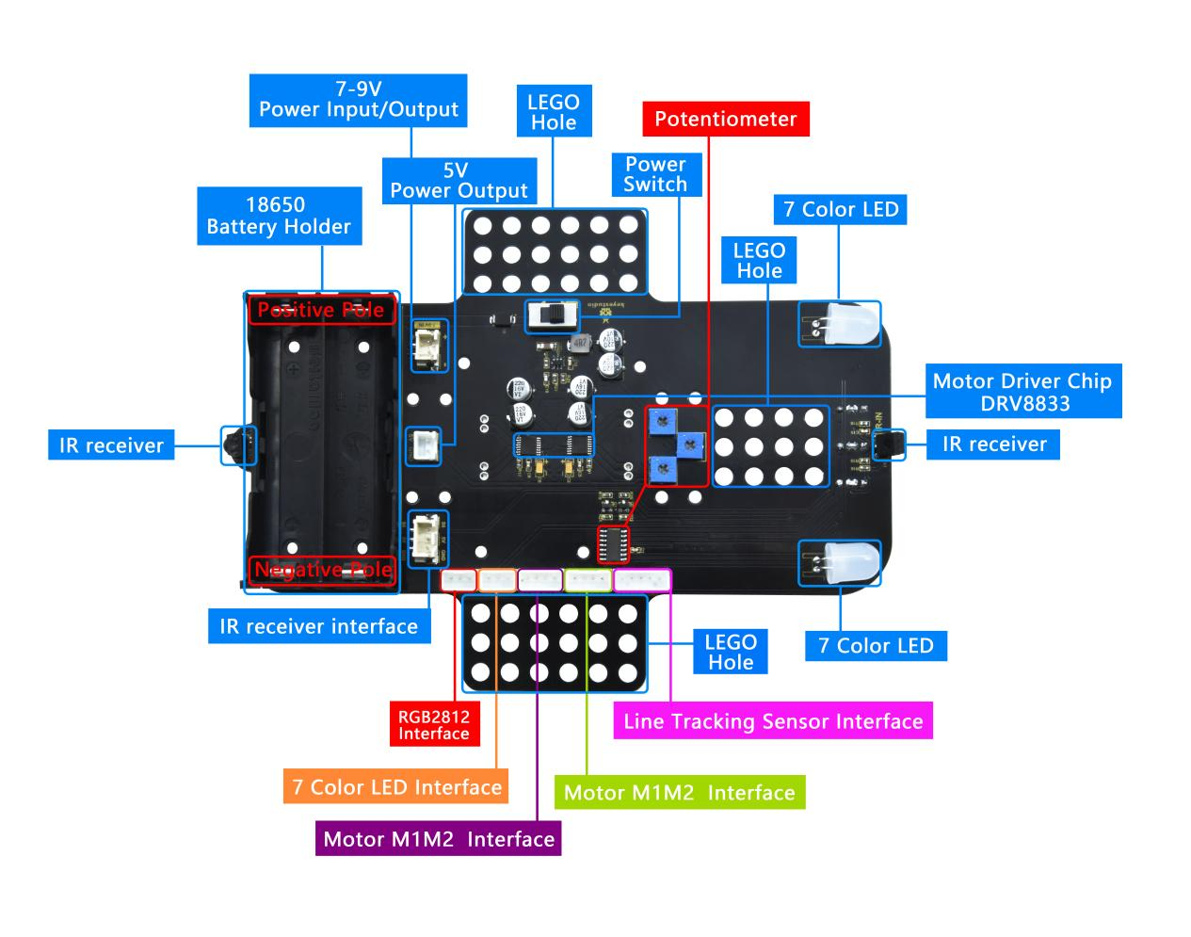

**Front**

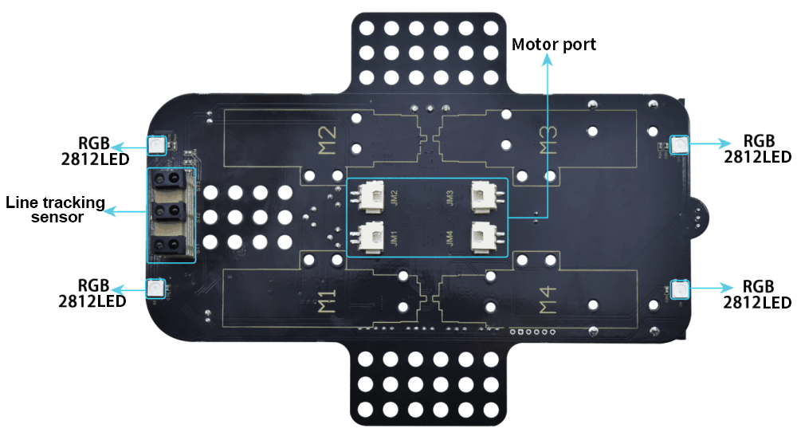

Back

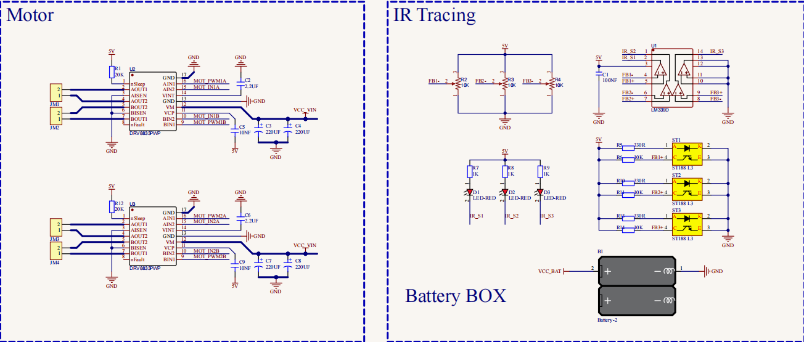

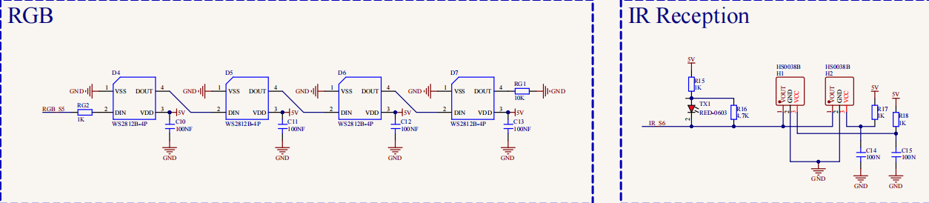

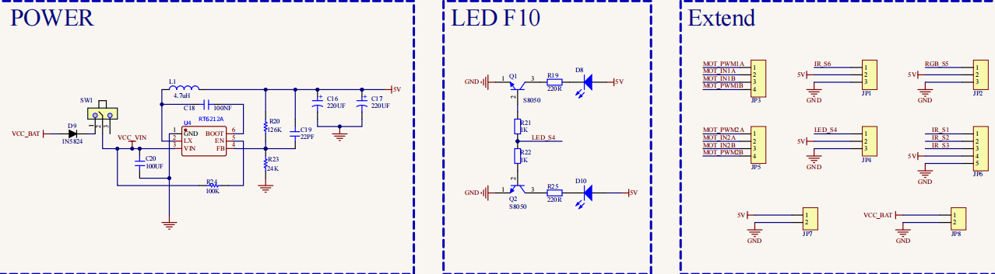

**Driver Board Circuit Diagram**